**Santa Barbara**

**Local Agency Formation Commission**

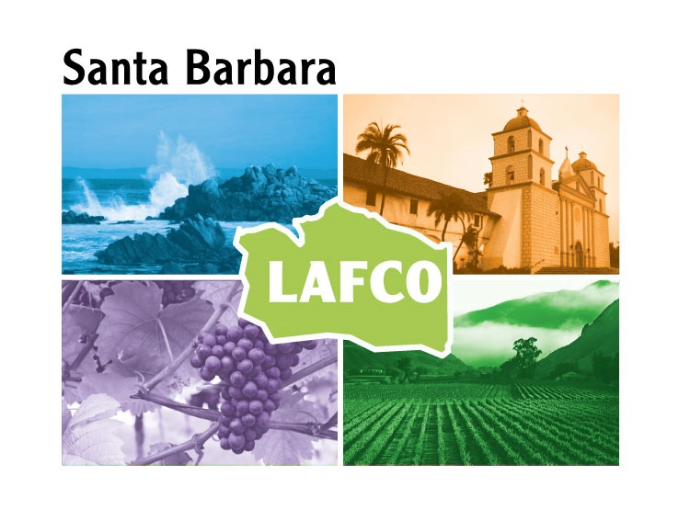

*Commissioner Cynthia Allen, Alternate*

*Commissioner Jay Freeman*

*Commissioner Craig Geyer*

*Commissioner Joan Hartmann*

*Commissioner James Kyriaco, Alternate*

*Commissioner Bob Nelson, Alternate*

*Commissioner Jenelle Osborne*

*Commissioner Alice Patino*

*Commissioner Jim Richardson, Alternate*

*Commissioner Shane Stark*

*Commissioner Das Williams*

**Minutes**

Thursday, August 3, 2023

1:00 PM

**JOSEPH CENTENO BETTERAVIA GOVERNMENT ADMINISTRATION BUILDING BOARD HEARING ROOM**

**511 EAST LAKESIDE PARKWAY**

**SANTA MARIA**

Meetings, Agendas, Supplemental Materials and Minutes of the Local Agency Formation Commission are available on the internet: [www.sblafco.org](http://www.sblafco.org)

**1:00 P.M. …. Call to Order**

**Roll Call**

**Present: 10 –** Commissioner Allen, Commissioner Freeman, Commissioner Geyer, Commissioner Hartmann, Commissioner Kyriaco, Commissioner Nelson, Commissioner Patino, Commissioner Richardson, Commissioner Stark, and Commissioner Williams

**Absent: 1 –** Commissioner Osborne

*Commissioner Kyriaco voted in Commissioner Osborne’s absence. Commissioner

Nelson voted in place of Commissioner Williams until he arrived at the meeting at 1:04 p.m.

and Commissioner Allen voted in place of Commissioner Freeman until he arrived at the

meeting at 1:06 p.m.

**Pledge of Allegiance**

**Approval of Minutes of the May 4, 2023 Regular Meeting**

**A motion was made by Commissioner Patino, seconded by Commissioner Nelson to approve the minutes**

**The motion carried by the following vote:**

**Ayes:** **7 –** Commissioner Allen, Commissioner Geyer, Commissioner Kyriaco, Commissioner Patino, Commissioner Stark, Commissioner Nelson and Commissioner Hartmann

**Public Comment Period**

**No requests to speak.**

**Consent Calendar**

1. Receive and file a report on Disbursements for May, June and July, 2023.
2. Consider amendment to the 2023 Commission Regular Meeting Schedule by changing location of Commission’s September 7th and November 2nd meeting and update the calendar to reflect that there will not be any remote testimony locations between July 19th and November 7, 2023.
3. Receive and file 2022-2023 Year-End Report.
4. Consider Resolution Approving the Filing of State Disability Insurance or Paid Family Leave Application for Elective Coverage under Section 709 of the Unemployment Insurance Code.

**A motion was made by Commissioner Stark, seconded by Commissioner Geyer to approve the Consent Calendar.**

**The motion carried by the following vote:**

**Ayes: 7 –** Commissioner Allen, Commissioner Geyer, Commissioner Kyriaco, Commissioner Patino, Commissioner Stark, Commissioner Williams, and Commissioner Hartmann

**RESOLUTION NO. 23-13 was assigned to Consent Calendar Item No. 4-**

**Filing of State Disability Insurance or Paid Family Leave Application for Elective Coverage under Section 709 of the Unemployment Insurance Code**

**(Note: Resolution number assigned by staff after the hearing)**

**Business Items**

1. Consider creation of and appointment of Commission members to an ad-hoc committee to review and make recommendations regarding future Commission policies covering agricultural-urban interface concerns.

**The Commission directed staff to bring the workshop format and status**

**update timeline back to the Commission at a future meeting.**

**No action taken.**

1. Regarding LAFCO annual audits, consider the following:
2. Review two proposals for preparation of a LAFCO fiscal audit and consider Executive Officer’s recommendation to approve Davis Farr proposal to prepare the financial audit for fiscal year ending June 30, 2023 with LAFCO options for financial audits for fiscal years ending June 30, 2024, and 2025 in amounts not to exceed $12,500, $12,900, and $13,300. A final contract will be considered by the Commission at a future date.
3. Determine whether the Commission should authorize the Executive Officer to request Santa Barbara LAFCO’s inclusion in the Joint Multi-LAFCO Audit group.

**A motion was made by Commissioner Stark, seconded by Commissioner Kyriaco to approve the proposal by Davis Farr to prepare the financial audit for fiscal year ending June 30, 2023 with LAFCO options for financial audits for fiscal years ending June 30, 2024, and 2025 in amounts not to exceed $12,500, $12,900, and $13,300, and to authorize the Executive Officer to pursue Santa Barbara LAFCO’s inclusion in the Joint Multi-LAFCO Audit group.**

**The motion carried by the following vote:**

**Ayes: 7 –** Commissioner Freeman, Commissioner Geyer, Commissioner Kyriaco, Commissioner Patino, Commissioner Stark, Commissioner Williams, and Commissioner Hartmann

1. Consider recommendations regarding amendments to Commissioner Handbook and provide direction to staff to return at a future meeting with any changes and/or additions as needed to address the effect of the Regional Water Quality Board regulations and orders regarding the Carpinteria Valley and the discharge of brine from certain agricultural operations, especially cannabis operations, as follows:
   1. Section 7 II – Sphere of Influence Policies.
   2. Section 7 V – Policies Encouraging Conservation of Prime Agricultural Lands and Open Space Areas.
   3. Section 7 XII – Extending Urban Utility Services to Agricultural Parcels.
   4. Find that the proposed actions are not a "project" under California Environmental Quality Act Guidelines §15378(b)(5) in that they are organizational or administrative activities of the government that will not result in direct or indirect physical changes to the environment.

**A motion was made by Commissioner Stark, seconded by Commissioner Geyer directing staff to present the matter to County Agricultural Advisory Committee and provide an update to the Commission at a future meeting.**

**The motion carried by the following vote:**

**Ayes: 7 –** Commissioner Freeman, Commissioner Geyer, Commissioner Kyriaco, Commissioner Patino, Commissioner Stark, Commissioner Williams, and Commissioner Hartmann

1. Consider making nominations to the 2023-2024 CALAFCO Board of Directors and Select voting delegates for the 2023 CALAFCO Elections.

**Motion No. 1**

**A motion was made by Commissioner Williams, seconded by Commissioner Hartmann to nominate Commissioner Stark for the 2023 CALAFCO Elections.**

**The motion carried by the following vote:**

**Ayes: 7 –** Commissioner Freeman, Commissioner Geyer, Commissioner Kyriaco, Commissioner Patino, Commissioner Stark, Commissioner Williams, and Commissioner Hartmann

**Motion No. 2**

**A motion was made by Commissioner Hartmann, seconded by Commissioner Freeman to nominate Executive Office Mike Prater as the Voting Member and Commissioner Stark as the Alternate for the 2023 CALAFCO Elections.**

**The motion carried by the following vote:**

**Ayes: 7 –** Commissioner Freeman, Commissioner Geyer, Commissioner Kyriaco, Commissioner Patino, Commissioner Stark, Commissioner Williams, and Commissioner Hartmann

1. Consider making nominations for the 2023 CALAFCO Achievement Awards and provide direction to staff.

**No action taken.**

1. Consider position on Assembly Bill 399 (Boerner) that proposes to amend the uncodified County Water Act of 1943 in order to changes the procedure for member agencies to detach from a county water authority.  Executive Officer Recommendation – Oppose

**No action taken.**

**Information Items**

1. Receive and file a report on the 2023 CALAFCO Annual Conference in Monterey, October 18-20, 2023 and provide direction to staff as necessary.

**No action taken.**

1. Receive and file a report on the CALAFCO Legislative Committee meetings held on May 5, 2023 and June 16, 2023.

**No action taken.**

**Commissioner and Staff Announcements**

1. Commissioner announcements and requests for future agenda items.
2. Executive Officer comments.

**Adjourn to**

**Regular Meeting on September 7, 2023*.***

**Joseph Centeno Betteravia Government Administration Building Board Hearing Room**

**511 East Lakeside Parkway**

**Santa Maria**

*Materials Submitted After Distribution of Packet - Materials related to an item on this agenda submitted after distribution of the agenda packet will be available on the Commission website at:* [*http://www.sblafco.org/*](http://www.sblafco.org/)*, subject to the ability to post the documents prior to the meeting.*

*Notice of Disability Accommodations - Persons with a disability who require any disability-related modification or accommodation, in order to participate in the meeting are asked to contact the LAFCO office at least three (3) days prior to the meeting by telephone at 805-568-2240 or by email at* [*lafco@sblafco.org*](mailto:lafco@sblafco.org)*.*